**Top 20 Git Commands with Example**

[***Git & GitHub certification***](https://www.edureka.co/git-github-sp) has steadily risen from being just a preferred skill to a must-have skill for multiple job roles today. In this blog, I will talk about the Top 20 Git Commands that you will be using frequently while you are working with Git.

Following are the  Git commands which are being covered:

* [**git config**](https://www.edureka.co/blog/git-commands-with-example/#git%20config)
* [**git init**](https://www.edureka.co/blog/git-commands-with-example/#git%20init)
* [**git clone**](https://www.edureka.co/blog/git-commands-with-example/#git%20clone)
* [**git add**](https://www.edureka.co/blog/git-commands-with-example/#git%20add)
* [**git commit**](https://www.edureka.co/blog/git-commands-with-example/#git%20commit)
* [**git diff**](https://www.edureka.co/blog/git-commands-with-example/#git%20diff)
* [**git reset**](https://www.edureka.co/blog/git-commands-with-example/#git%20reset)
* [**git status**](https://www.edureka.co/blog/git-commands-with-example/#git%20status)
* [**git rm**](https://www.edureka.co/blog/git-commands-with-example/#git%20rm)
* [**git log**](https://www.edureka.co/blog/git-commands-with-example/#git%20log)
* [**git show**](https://www.edureka.co/blog/git-commands-with-example/#git%20show)
* [**git tag**](https://www.edureka.co/blog/git-commands-with-example/#git%20tag)
* [**git branch**](https://www.edureka.co/blog/git-commands-with-example/#git%20branch)
* [**git checkout**](https://www.edureka.co/blog/git-commands-with-example/#git%20checkout)
* [**git merge**](https://www.edureka.co/blog/git-commands-with-example/#git%20merge)
* [**git remote**](https://www.edureka.co/blog/git-commands-with-example/#git%20remote)
* [**git push**](https://www.edureka.co/blog/git-commands-with-example/#git%20push)
* [**git pull**](https://www.edureka.co/blog/git-commands-with-example/#git%20pull)
* [**git stash**](https://www.edureka.co/blog/git-commands-with-example/#git%20stash)

So, let’s get started now!!

**Git Commands**

**git config**

**Usage: git config –global user.name “[name]”**

**Usage: git config –global user.email “[email address]”**

This command sets the author name and email address respectively to be used with your commits.

Git Config Command - Git Commands - Edureka

**git init**

**Usage: git init [repository name]**

This command is used to start a new repository.

GitInit Command - Git Commands - Edureka

**git clone**

**Usage: git clone [url]**

This command is used to obtain a repository from an existing URL.

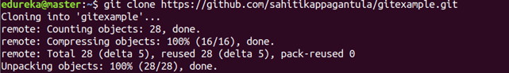

**git add**

**Usage: git add [file]**

This command adds a file to the staging area.

Git Add Command - Git Commands - Edureka

**Usage: git add \***

This command adds one or more to the staging area.

Git Add Command - Git Commands - Edureka

**git commit**

**Usage: git commit -m “[ Type in the commit message]”**

This command records or snapshots the file permanently in the version history.

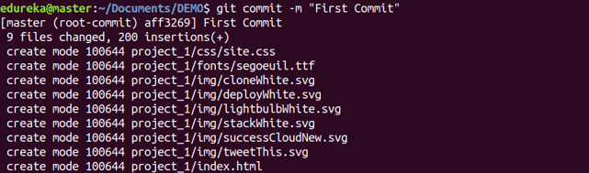

**Usage: git commit -a**

This command commits any files you’ve added with the git add command and also commits any files you’ve changed since then.

Git Commit Command - Git Commands - Edureka

**git diff**

**Usage: git diff**

This command shows the file differences which are not yet staged.

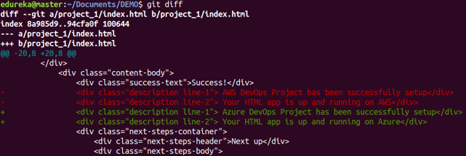

**Usage: git diff –staged**

This command shows the differences between the files in the staging area and the latest version present.

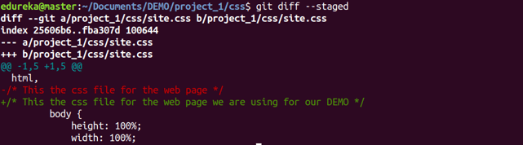

**Usage: git diff [first branch] [second branch]**

This command shows the differences between the two branches mentioned.

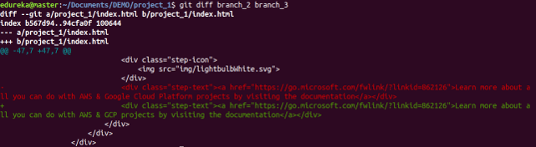

**Git Commands With Examples | Edureka**

**git reset**

**Usage: git reset [file]**

This command unstages the file, but it preserves the file contents.

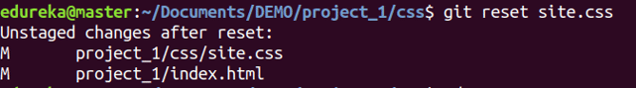

**Usage: git reset [commit]**

This command undoes all the commits after the specified commit and preserves the changes locally.

Git Reset Command - Git Commands - Edureka

**Usage: git reset –hard [commit]**

This command discards all history and goes back to the specified commit.

Git Reset Command - Git Commands - Edureka

**git status**

**Usage: git status**

This command lists all the files that have to be committed.

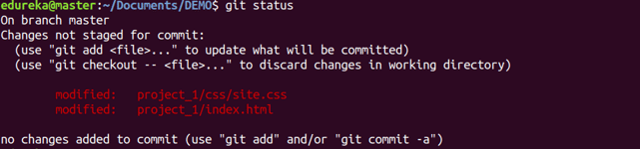

**git rm**

**Usage: git rm [file]**

This command deletes the file from your working directory and stages the deletion.

Git Rm Command - Git Commands - Edureka

**git log**

**Usage: git log**

This command is used to list the version history for the current branch.

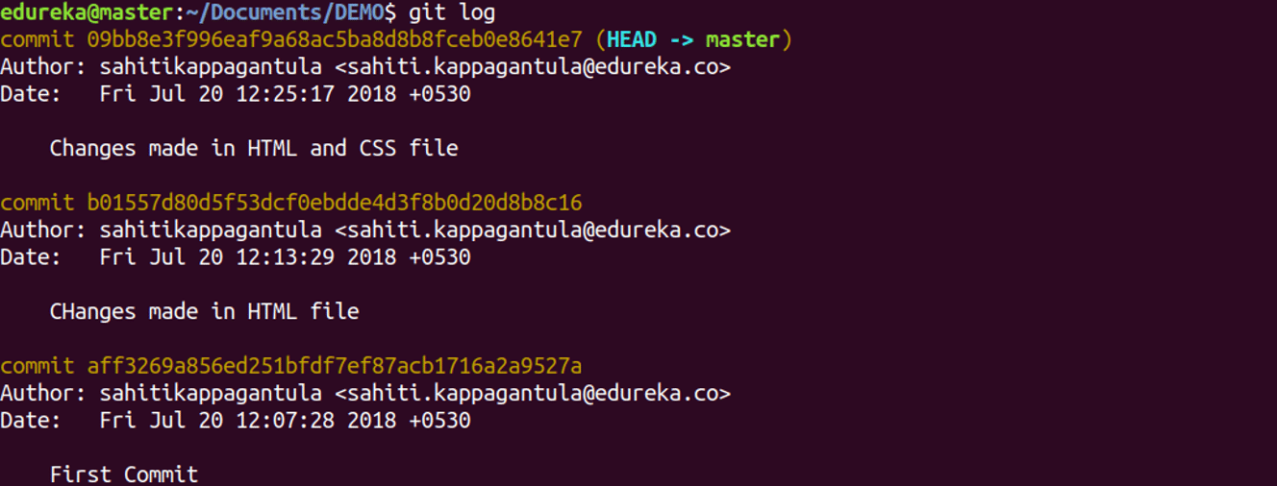

**Usage: git log –follow[file]**

This command lists version history for a file, including the renaming of files also.

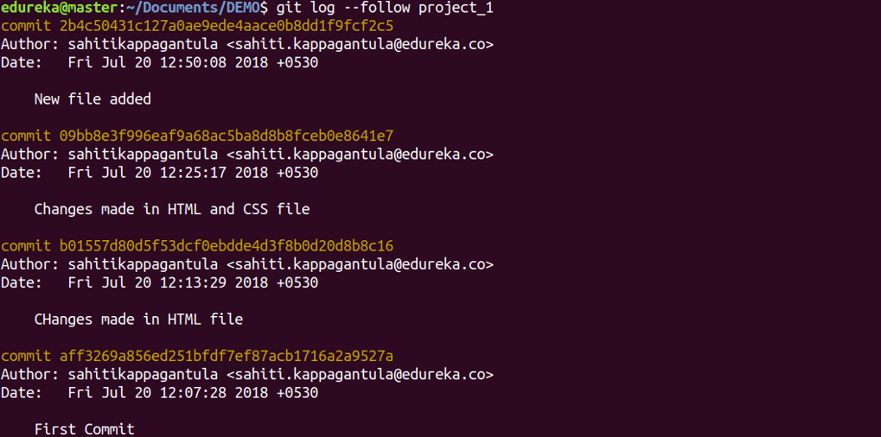

**git show**

**Usage: git show [commit]**

This command shows the metadata and content changes of the specified commit.

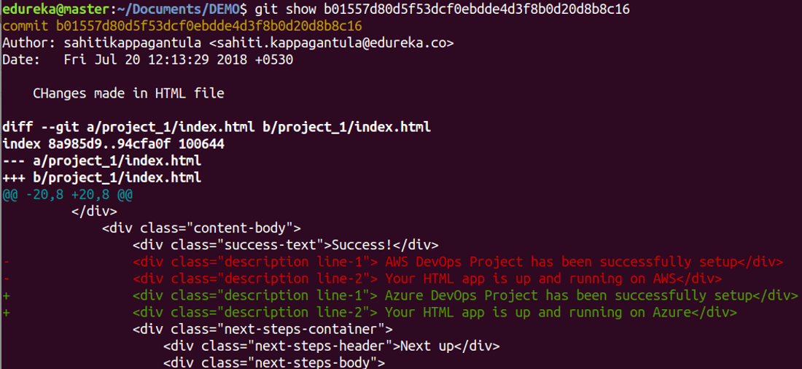

**git tag**

**Usage: git tag [commitID]**

This command is used to give tags to the specified commit.

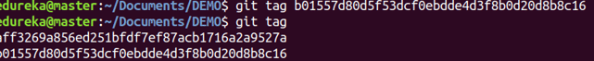

**git branch**

**Usage: git branch**

This command lists all the local branches in the current repository.

Git Branch Command - Git Commands - Edureka

**Usage: git branch [branch name]**

This command creates a new branch.

Git Branch Command - Git Commands - Edureka

**Usage: git branch -d [branch name]**

This command deletes the feature branch.

Git Branch Command - Git Commands - Edureka

**git checkout**

**Usage: git checkout [branch name]**

This command is used to switch from one branch to another.

Git Checkout Command - Git Commands - Edureka

**Usage: git checkout -b [branch name]**

This command creates a new branch and also switches to it.

Git Checkout Command - Git Commands - Edureka

**git merge**

**Usage: git merge [branch name]**

This command merges the specified branch’s history into the current branch.

Git Merge Command - Git Commands - Edureka

**git remote**

**Usage: git remote add [variable name] [Remote Server Link]**

This command is used to connect your local repository to the remote server.

Git Remote Command - Git Commands - Edureka

**git push**

**Usage: git push [variable name] master**

This command sends the committed changes of master branch to your remote repository.

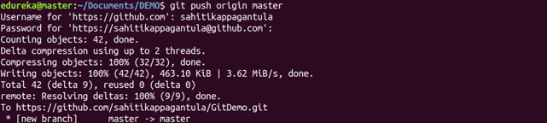

**Usage: git push [variable name] [branch]**

This command sends the branch commits to your remote repository.

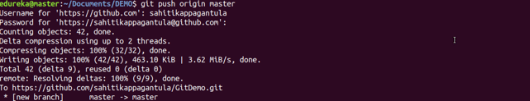

**Usage: git push –all [variable name]**

This command pushes all branches to your remote repository.

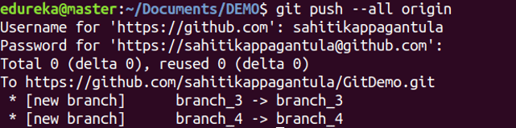

**Usage: git push [variable name] :[branch name]**

This command deletes a branch on your remote repository.

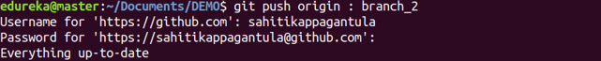

**git pull**

**Usage:  git pull [Repository Link]**

This command fetches and merges changes on the remote server to your working directory.

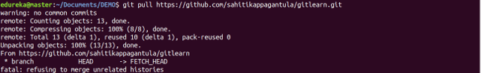

**git stash**

**Usage: git stash save**

This command temporarily stores all the modified tracked files.

Git Stash Command - Git Commands - Edureka

**Usage: git stash pop**

This command restores the most recently stashed files.

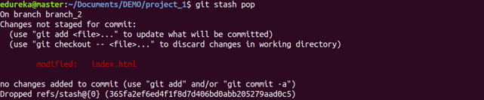

**Usage: git stash list**

This command lists all stashed changesets.

Git Stash Command - Git Commands - Edureka

**Usage: git stash drop**

This command discards the most recently stashed changeset.

Git Stash Command - Git Commands - Edureka

Want to learn more about git commands? Here is a [**Git Tutorial**](https://www.edureka.co/blog/git-tutorial/) to get you started. Alternatively, you can take a top-down approach and start with this[**DevOps Tutorial.**](https://www.edureka.co/blog/devops-tutorial)